IR Protocols
Phillips RC5 infrared remote protocol
Most audio and video systems are equipped with an infrared remote control. A common used standard protocol for infrared data communication is the RC5 code, originally developed by Phillips. This code has an instruction set of 2048 different instructions and is divided into 32 address of each 64 instructions. Every kind of equipment use his own address,so this makes it possible to change the volume of the TV without change the volume of the hifi. The transmitted code is a dataword wich consists of 14 bits and is defined as:

2 startbits for the automatic gain control in the infrared receiver.
1 toggle bit (change everytime when a new button is pressed on the ir transmitter)
5 address bits for the systemaddress
6 instructionbits for the pressed key
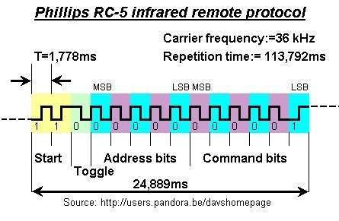

The picture under are waveforms from my digital oscilloscope of rc5 codes with pushed buttons 1,2,3,4. You can good see the startbits and the toggle bit (These are inverted signals because they were captured directly on the TSOP1836).
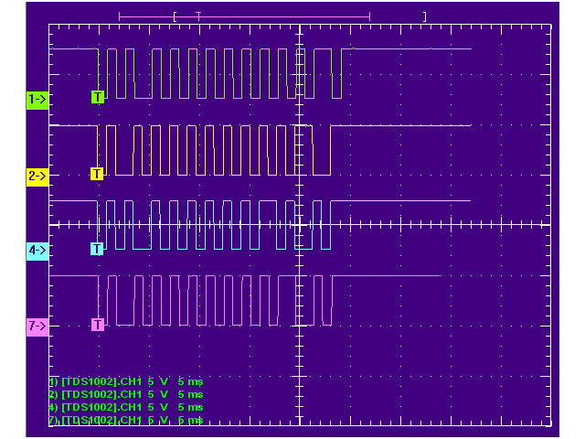
The RC5 code uses the bifase modulation technic which means that every bit consists of 2 parts which are never the same.
So a bit is always a high/low or a low/high transisition. By the RC5 code a 1 is a low high transisition
and a 0 is high low transisition. For all the bits the most significant bit is transmitted first.
Remember also that the outputsignal of the integrated receivers is inverted:
Detecting an IR signal the output of the integrated receiver will be 0V.
The duration time of each bit is equal to 1,778 ms, and the total time of a full rc5 code is 24,778 ms.
The space between two transmitted codes is 50 bit times or 88,889ms.
To improve noise rejection the pulses are modulated at a carrier frequence
The carrier frequency of the rc5 code is 36 kHz so take always a receiver with a response
frequency of 36 kHz.

Daewoo infrared remote protocol
By the Daewoo protocol a logical 0 bit exists of a high puls with a duration time of 550 µs followed
by a low puls of 450 µs this means that the total duration time of a logical zero bit is 1ms.
A logical 1 bit is formed by a high on time of 550 µs followed by low signal of 1450 µs this means
also that the total duration time of a logical one bit is 2 ms.
The carrier frequency of the infrared signal is 38 kHz. When you will decode the signal with an
integrated receiver module you need a receiver module wich is tuned on 38 kHz like the TSOP1838
fabricated by Vishay. It will function also with a 36 kHz module but the sensitivity is less than by a
38 kHz module.
Because the receiver (mostly in hobby applications a microprocessor) needs to trigger on a new
received code the protocol starts with a start bit of 8ms high level pulse and a 4 ms low level pulse.
After this the 7 address bits and 7 command bits are sent. But the two words are divided by a 550µs
high level signal and 4ms low level signal. Terminating the protocol is done with an another
high level signal of 550µs.
The time between two startbits of bitstreams when the button on the remote control is being pressed =60 ms.

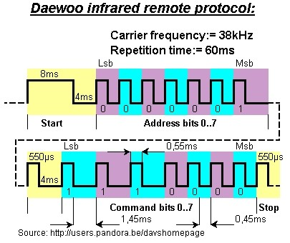

The sony ir code
The Sony remote control is based on the Pulse-Width signal coding scheme.
The code exists of 12 bits sent on a 40kHz carrier wave. The code starts with a header of 2,4ms or
4 times T where T is 600µS. The header is followed by 7 command bits and 5 adres bits.
The address and commands exists of logical ones and zeros. A logical one is formed by
a space of 600µS or 1T and a pulse of 1200 µS or 2T. A logical zero is formed by a space of 600 µS
and pulse of 600µS.
The space between 2 transmitted codes when a button is being pressed is 40mS
The bits are transmitted least significant bits first. The total length of a bitstream is always 45ms.

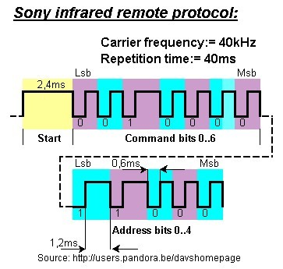

The following bitmaps are waveforms measured with a digital oscilloscope. The signals were transmitted with a sony remote control

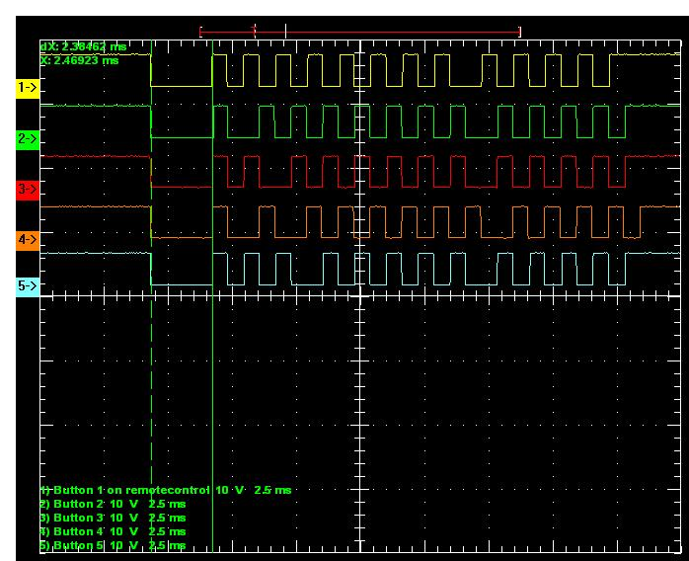

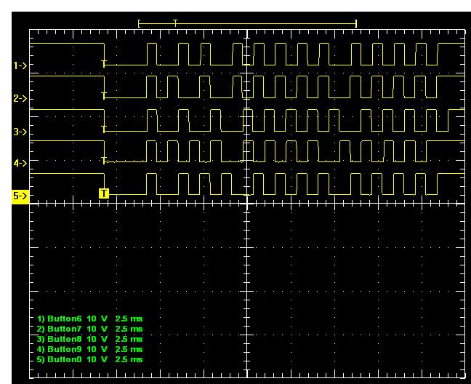

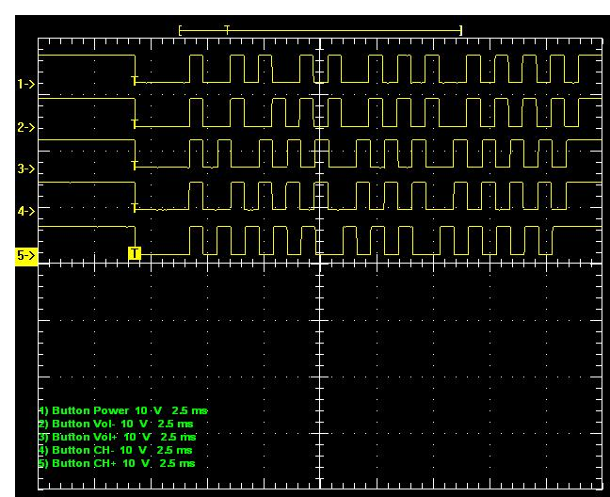

JVC infrared remote protocol
The JVC infrared remote protocol is almost equal to the daewoo protocol.
It are just the timings and the spacer between the address and data bits who differs a little bit.
By the JVC protocol a logical 0 bit exists of a high puls with a duration time of 600 µs followed
by a low puls of 550 µs this.
A logical 1 bit is formed by a high on time of 600 µs followed by low signal of 1600 µs.
The carrier frequency of the infrared signal is 38 kHz. When you will decode the signal with an
integrated receiver module you need a receiver module wich is tuned on 38 kHz like the TSOP1838
fabricated by Vishay. It will function also with a 36 kHz module but the sensitivity is less than by a
38 kHz module.
Because the receiver (mostly in hobby applications a microprocessor) needs to trigger on a new
received code the protocol starts with a start bit of 8ms high level pulse and a 4 ms low level pulse.
After this the 7 address bits and 7 command bits are transmitted.
Terminating the protocol is done with an another high level signal of 600µs.
The time between two startbits of bitstreams when the button on the remote control is being pressed =
60 ms but the start header is only once transmitted in the beginning of the keypress.
